Men’s & Ladies Senior Open
Golf NSW SOOM Event

Event Details
Date: Thursday 7th September 2023
Tee Off: 09:51AM – 12:11AM
Event: 18 Holes Stroke Gross & Nett

Entry Fee: Members $40 / Visitors $50 (Must accompany this entry form)

Entries Close: 5th September 2023

______________ ______________ _________ _____ ____________ __________
Name (print) Club Golflink# H/C Phone#

______________ ______________ _________ _____ ____________ __________
Name (print) Club Golflink# H/C Phone#

______________ ______________ _________ _____ ____________ __________
Name (print) Club Golflink# H/C Phone#

______________ ______________ _________ _____ ____________ __________
Name (print) Club Golflink# H/C Phone#

Payment by Credit Card MasterCard / Visa (please indicate)

Card No. __ __ __ __ __ __ __ __ __ __ __ __ __ __ __ __ Expires: __ __ / __ __

Cardholders Name: _________________ ccv # (3 digits on back of card) _______________

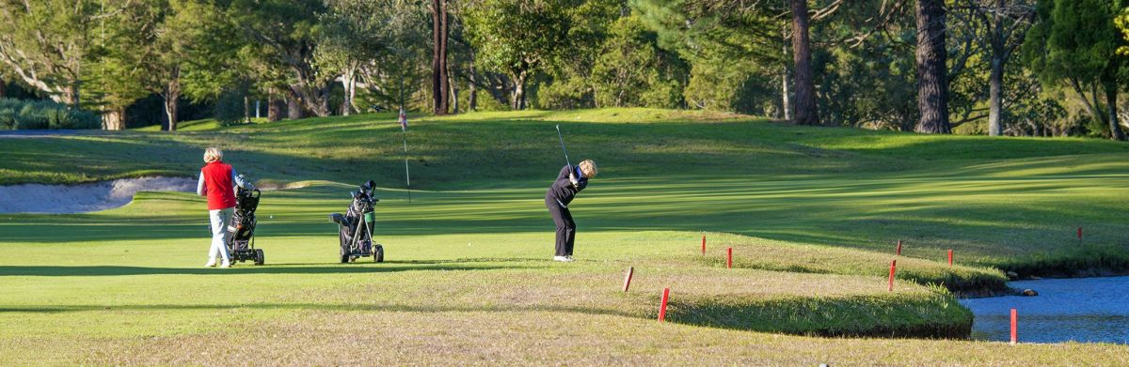
PLEASE NOTE PLAYERS MUST BE OVER 50 YEARS OF AGE

Please return to Gosford Golf Club
Email: golf@gosfordgolf.com.au
(Emailed entries only accepted with credit card payments)
- Please reply with a preferred time

